EXERCISE 1: CREATE A SPRING WEB PROJECT USING MAVEN

SpringLearnApplication.java:
package com.cognizant.spring_learn;

import org.springframework.boot.SpringApplication;
import org.springframework.boot.autoconfigure.SpringBootApplication;

@SpringBootApplication
public class SpringLearnApplication {

public static void main(String[] args) {
SpringApplication.run(SpringLearnApplication.class, args);

// 👇 Output statements
System.out.println("========================================");
System.out.println("✅ Spring Boot Application Started");
System.out.println("🌐 Try opening: http://localhost:8080");
System.out.println("========================================");
}
}
OUPUT:
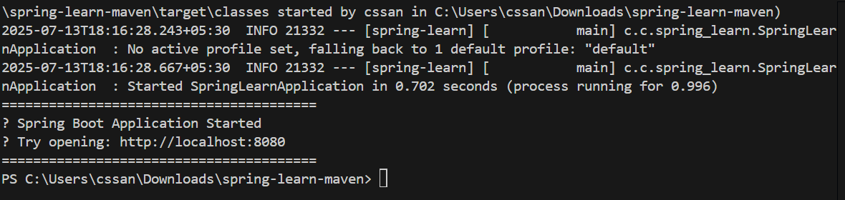

EXERCISE 2: SPRING CORE – LOAD COUNTRY FROM SPRING CONFIGURATION XML

SpringLearnApplication.java:
package com.cognizant.spring_learn;

import org.springframework.context.ApplicationContext;
import org.springframework.context.support.ClassPathXmlApplicationContext;

public class SpringLearnApplication {
public static void main(String[] args) {
displayCountry();
}

public static void displayCountry() {
ApplicationContext context = new ClassPathXmlApplicationContext("country.xml");
Country country = (Country) context.getBean("country", Country.class);
System.out.println("Country: " + country.toString());
}
}
OUTPUT:
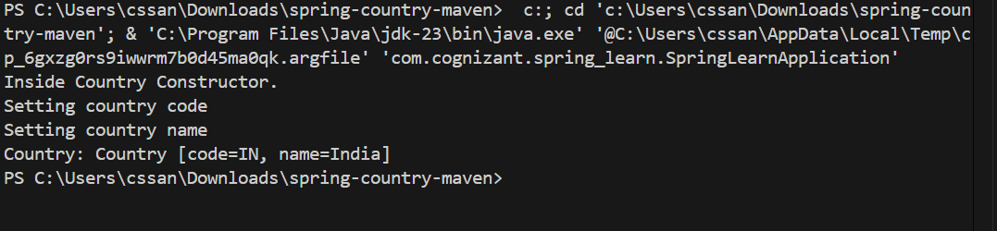

EXERCISE 3: HELLO WORD RESTful WEB SERVICES

HelloController.java:
package com.cognizant.springlearn.controller;

import org.slf4j.Logger;
import org.slf4j.LoggerFactory;
import org.springframework.web.bind.annotation.GetMapping;
import org.springframework.web.bind.annotation.RestController;

@RestController
public class HelloController {

private static final Logger LOGGER = LoggerFactory.getLogger(HelloController.class);

@GetMapping("/hello")
public String sayHello() {
LOGGER.info("START - sayHello()");
String response = "Hello World!!";
LOGGER.info("Returning Response: {}", response);
LOGGER.info("END - sayHello()");
return response;
}

}
}

OUTPUT:
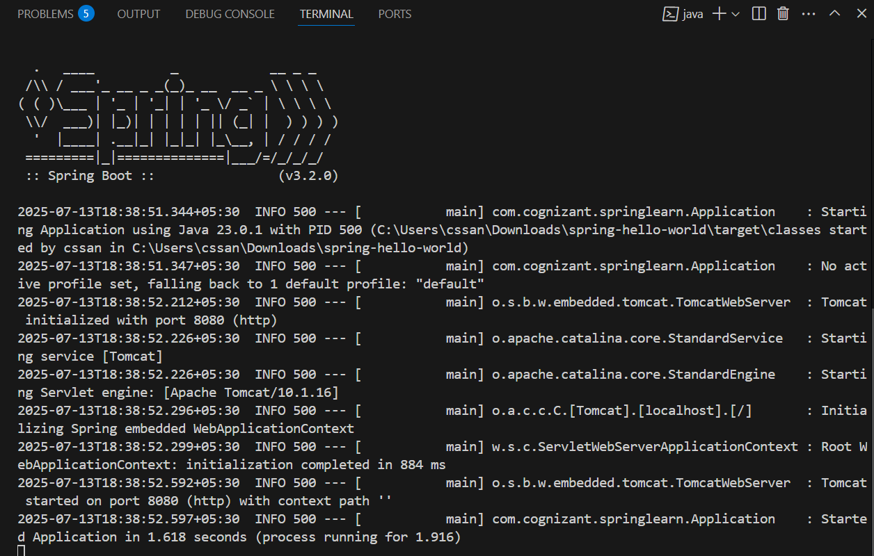
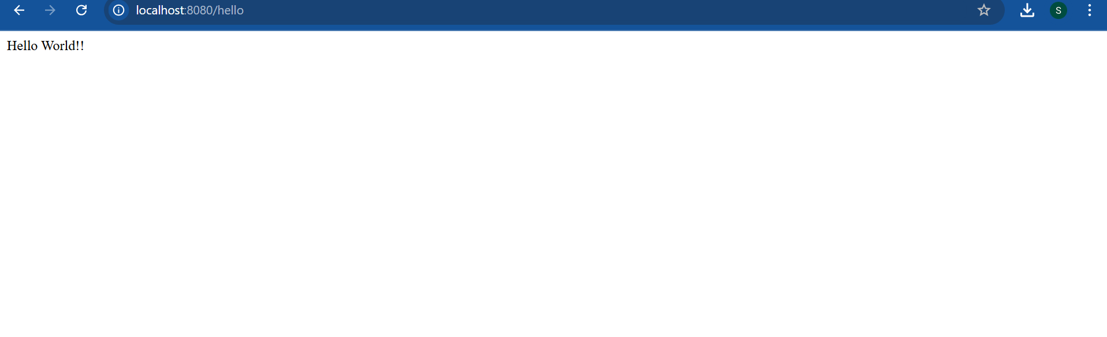

EXERCISE 4: REST – COUNTRY WEB SERVICES
CountryController.java:
package com.cognizant.springlearn.controller;
import com.cognizant.springlearn.model.Country;
import org.slf4j.Logger;
import org.slf4j.LoggerFactory;
import org.springframework.context.ApplicationContext;
import org.springframework.context.support.ClassPathXmlApplicationContext;
import org.springframework.web.bind.annotation.GetMapping;
import org.springframework.web.bind.annotation.RestController;
@RestController
public class CountryController {
private static final Logger LOGGER = LoggerFactory.getLogger(CountryController.class);
@GetMapping("/country")
public Country getCountryIndia() {
LOGGER.info("START - getCountryIndia()");
ApplicationContext context = new ClassPathXmlApplicationContext("country.xml");
Country country = (Country) context.getBean("in");
LOGGER.info("END - getCountryIndia()");
return country;
}
}
OUTPUT:
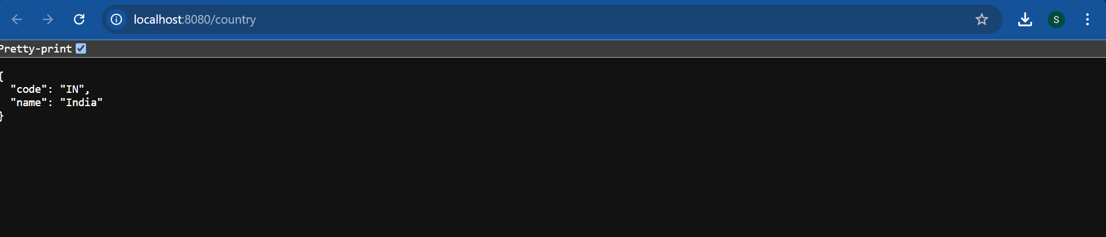

EXERCISE 5: GET COUNTRY BASED ON COUNTRY CODE

Application .java:
package com.cognizant.springlearn;

import org.springframework.boot.SpringApplication;
import org.springframework.boot.autoconfigure.SpringBootApplication;

@SpringBootApplication
public class Application {
public static void main(String[] args) {
SpringApplication.run(Application.class, args);
}
}
OUTPUT:
